Functional Requirements Document (FRD)

**(Online Grocery App)**

**1. Introduction**

**1.1 Purpose**

The purpose of this document is to specify the functional requirements for integrating a new shopping category, "Kitchen Appliances," into the existing online grocery app called ‘Fresho’. This feature enhancement aims to provide users with a seamless shopping experience for groceries and kitchen appliances.

**1.2 Scope**

The scope of this document covers the functionalities required for users to browse, select, purchase, and manage kitchen appliances within the app. It also includes administrative functionalities for managing products, orders, and analytics related to kitchen appliances.

**1.3 Definitions, Acronyms, and Abbreviations**

- FRD: Functional Requirement Document

- UI: User Interface

- UX: User Experience

- API: Application Programming Interface

**2. Functional Requirements**

**2.1 User Module**

**2.1.1 Browse and Search**

- **Requirement**: Users should be able to browse and search for kitchen appliances separately from groceries.

- **Description:**

- Users can navigate to the "Kitchen Appliances" category from the main menu or search for specific appliances using keywords.

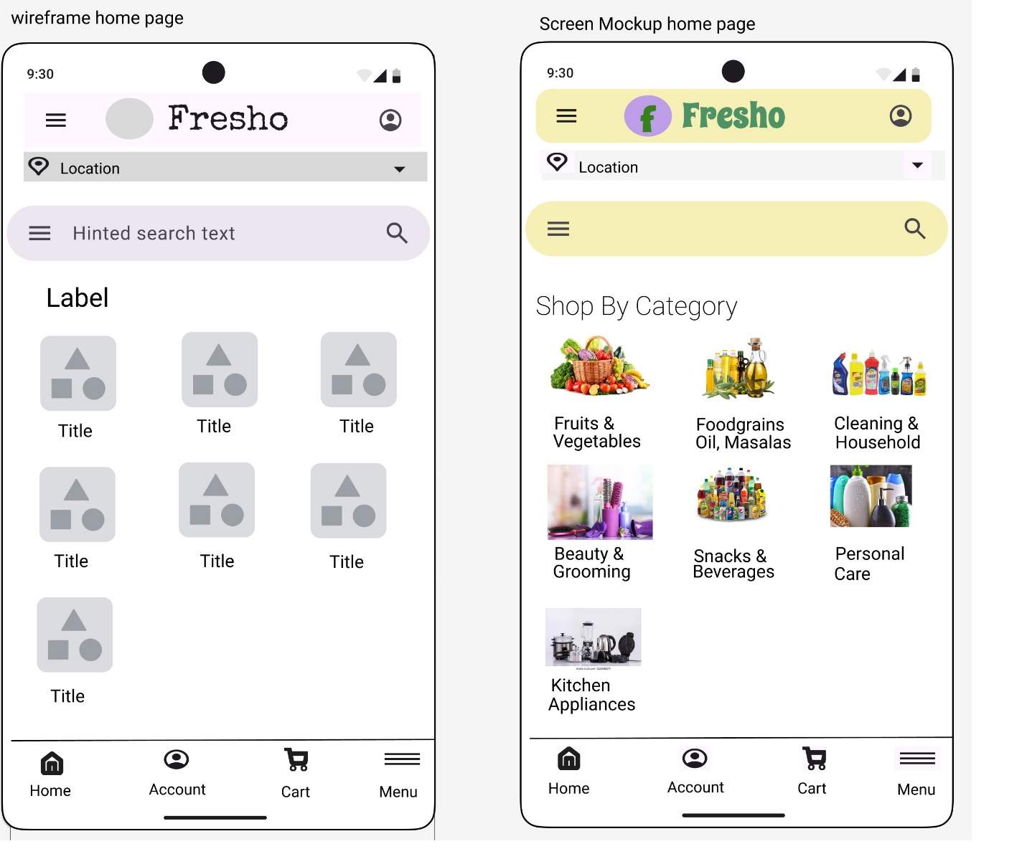

**2.1.2 Product Details**

- **Requirement:** User should be able to click on ‘Kitchen Appliances’ category which will include 3 more categories. Users should be able to click on any category to view list of products.

- **Description:**

- Display list of products with images, descriptions, specifications (e.g. price, rating, volume, customer reviews.)

- ‘Kitchen Appliances’ category should include storage & accessories, crockeries & utensils, kitchen accessories & bakeware categories.

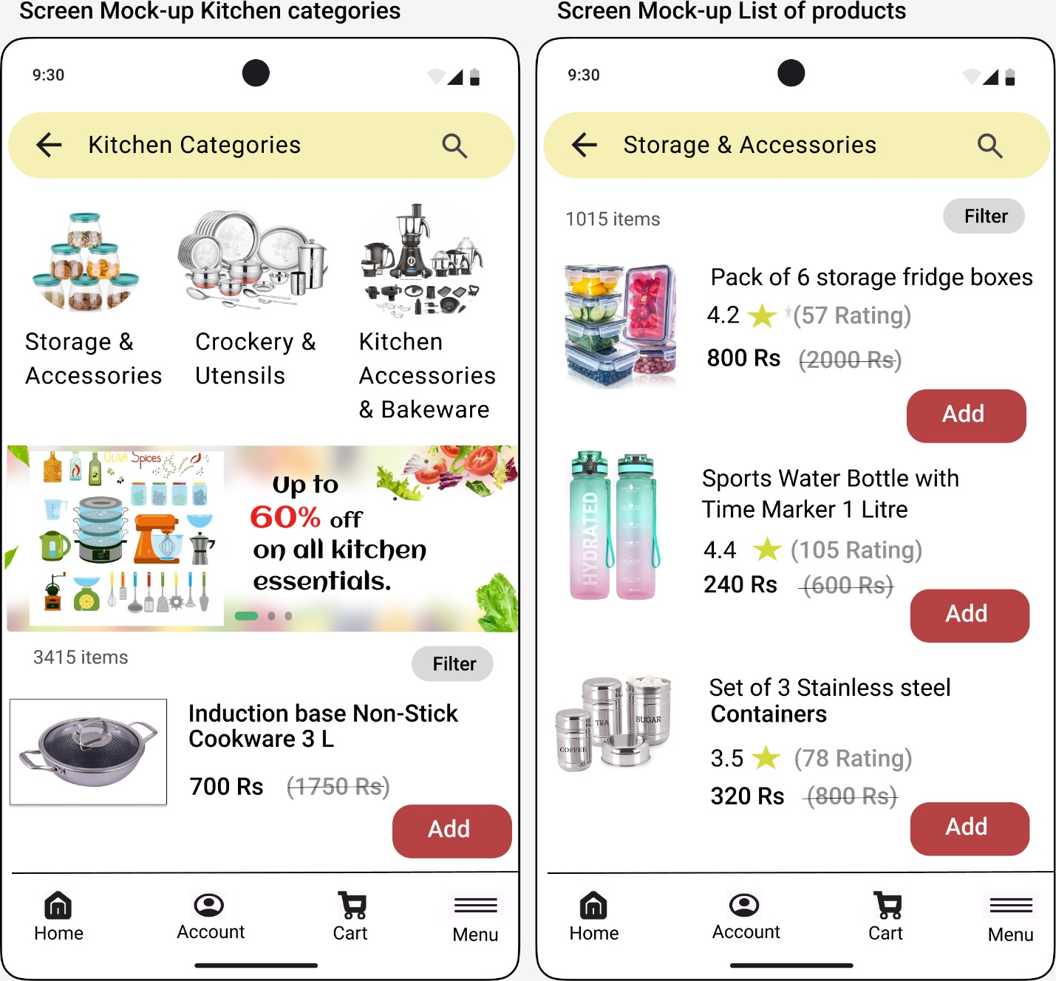

**2.1.3 Add to Cart and Checkout**

- **Requirement:** Users should be able to add kitchen appliances to their cart and complete the checkout process.

- **Description:**

- Users can add appliances to the cart, review items, and proceed to checkout.

- Support multiple payment options (credit/debit cards, digital wallets, COD).

- Include a seamless transition between adding groceries and appliances to the cart.

**2.1.4 Order Management**

- **Requirement:** Users should be able to track the status of their appliance orders.

- **Description:**

- Provide real-time order tracking with status updates (e.g., processing, shipped, delivered).

- Send notifications to users for order updates and delivery schedules.

**2.1.5 Customer Account**

- **Requirement:** Users should be able to manage their appliance orders and account settings.

- **Description:**

- Allow users to view order history, track deliveries, and manage returns or exchanges for appliances.

- Personalize user experience with recommendations based on appliance purchases.

**2.2 Admin Module**

**2.2.1 Dashboard and Analytics**

**- Requirement**: Admins should have access to analytics and management tools for kitchen appliances.

- **Description:**

- Provide a dashboard with sales performance metrics, inventory levels, and customer feedback specific to appliances.

- Generate reports on appliance sales trends, customer preferences, and revenue generated.

**2.2.2 Product Management**

- **Requirement:** Admins should be able to manage kitchen appliances within the app.

- **Description:**

- Add, edit, and delete appliance listings with details such as price, stock availability, and specifications.

- Manage appliance categories, brands, and promotional campaigns.

**2.2.3 Order Fulfillment**

- **Requirement:** Admins should be able to process appliance orders efficiently.

**- Description:**

- View and update order statuses, manage returns or cancellations, and coordinate with shipping partners for appliance deliveries.

- Ensure integration with existing order management systems for seamless operations.

**3. Non-Functional Requirements**

**3.1 Performance**

- **Requirement:** The app should handle simultaneous user interactions and transactions efficiently.

- **Description:**

- Maintain fast response times for browsing, searching, and adding products to the cart.

- Support peak loads during promotional events without performance degradation.

**3.2 Security**

**- Requirement:** Ensure secure handling of payment information and user data.

**- Description:**

- Implement encryption protocols for data transmission and storage.

- Comply with GDPR (General data protection regulation) and other data protection regulations.

**3.3 Usability**

**- Requirement:** Provide a user-friendly interface for seamless shopping across groceries and kitchen appliances.

**- Description:**

- Ensure consistent UI/UX design with intuitive navigation and responsive layouts.

- Seamless integration with existing categories.

**4. Assumptions and Dependencies**

**4.1 Assumptions**

- Users have internet access and compatible devices (smartphones, tablets, desktops) to access the app.

- Admins have access to a stable internet connection and necessary permissions to manage app functionalities.

**4.2 Dependencies**

- Integration with third-party APIs for payment processing (e.g.GPay, Paytm, PhonePe etc.) and shipping logistics (e.g., Delhivery, DTDC, Blue Dart etc.).

- Compatibility with existing backend systems (e.g., inventory management, CRM) for seamless data synchronization.

**5. Constraints**

**- Budget:** Development and integration costs should not exceed the allocated budget.

**- Timeline**: Feature implementation should align with scheduled release cycles and marketing campaigns.

**6. Risks and Mitigation Strategies**

**- Risk:** Potential delays in API integration or technical issues during implementation.

**- Mitigation:** Conduct thorough testing, establish clear communication channels with third-party providers, and implement a phased rollout strategy.

**7. Sign-off**

This Functional Requirement Document (FRD) is approved by:

|  |  |  |  |  |
| --- | --- | --- | --- | --- |
| **Role** | **Name** | **Title** | **Signature** | **Date** |
| Project Sponsor |  |  |  |  |
| Business Owner |  |  |  |  |
| Product Owner |  |  |  |  |
| System Architect |  |  |  |  |
| Development Lead |  |  |  |  |